Translated from German to English - www.onlinedoctranslator.com
12/27/2022

Long-term measurement of several KT88 (characteristic curve over time)
Experiment: How can thermal lattice emission be detected?
with conversion instructions/supplement G1 card
Long-term measurement of several KT88 (characteristic over time)Experiment: How to determine thermal grid emission?
with modification instructions/supplement G1 card

Translated to english language by Shaun Merrigan with Doc Translator. Thank you very much.

There were 6 pieces of KT88 available, mostly with abnormalities.

Tube 1:

Thread test: ok
Short circuit test: ok
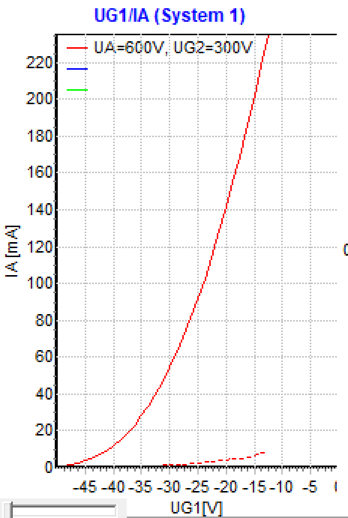
stat. Measurements:

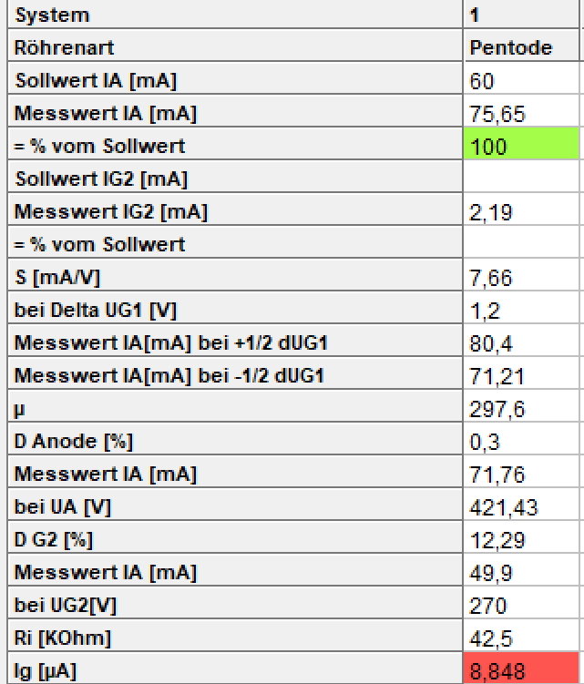 Vacuum test: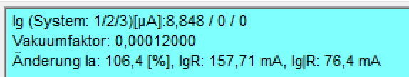

Time course (after approx. 30 seconds of pause/cooling down and restart):
(new alternating mode:red=hard G1 control,blue= grid over resistance)
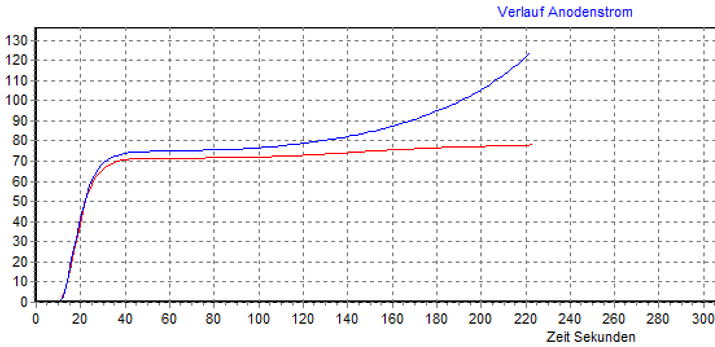

Ua 600V, Ug2 300V, Ug1 -27V,
RUg = 1.2 MOhm
Measurement every 1 second, sound test off
(tube cold)

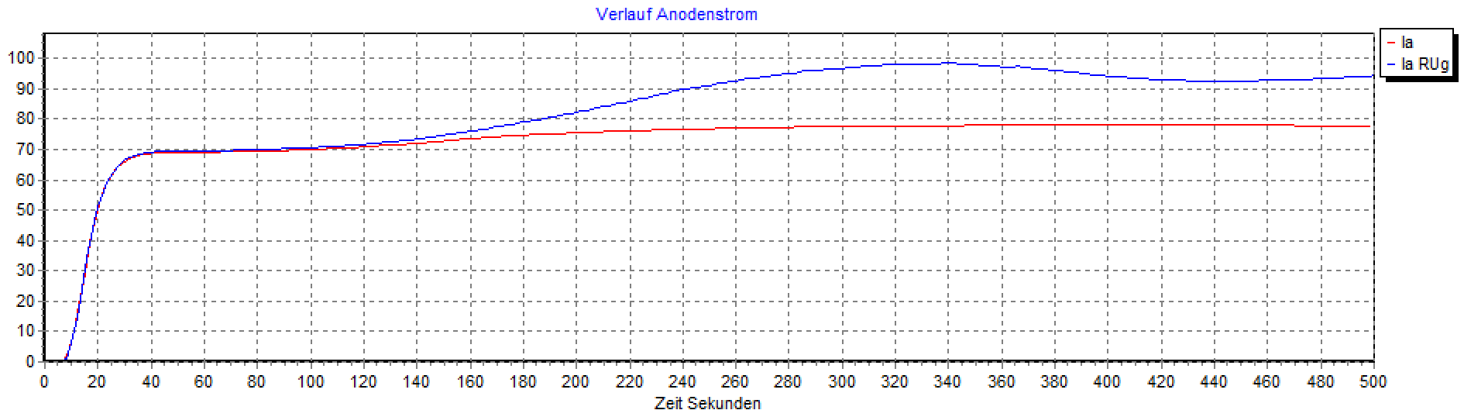
Ua 600V, Ug2 300V, Ug1 -27V, RUg= 200KOhm,
Measurement every 3 seconds, sound test off

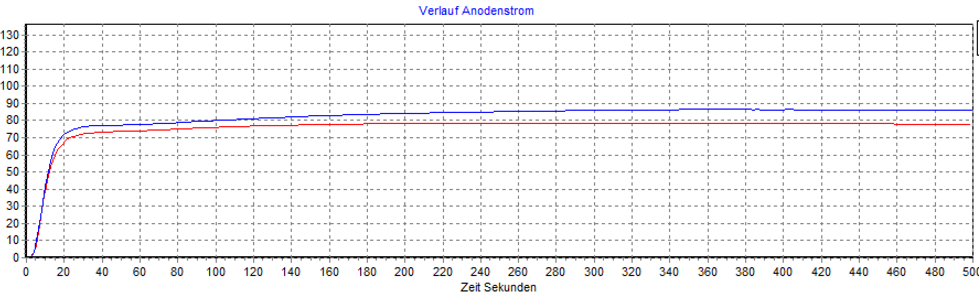
Ua 600V, Ug2 300V, Ug1 -35V, RUg= 100 KOhm
Measurement every 1 second, sound test off (tube a few S after measurement 1)

Conclusion:Tube has a lot of grid current. Tube runs out of time at high RUg (presumably thermal grid emission). At RUg 100 KOhm, the characteristic curve turns into a straight line. At 200 KOhm you can see a clear deviation (Pa-g2 56 watts, blue characteristic curve)

Tube 2:

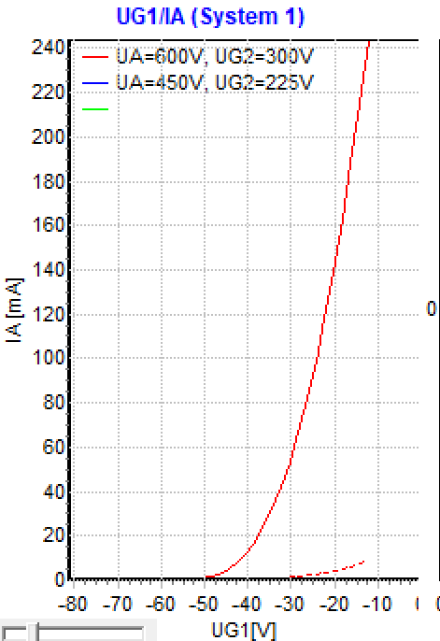
Thread test: ok, short circuit test: ok, stat. Measurements:
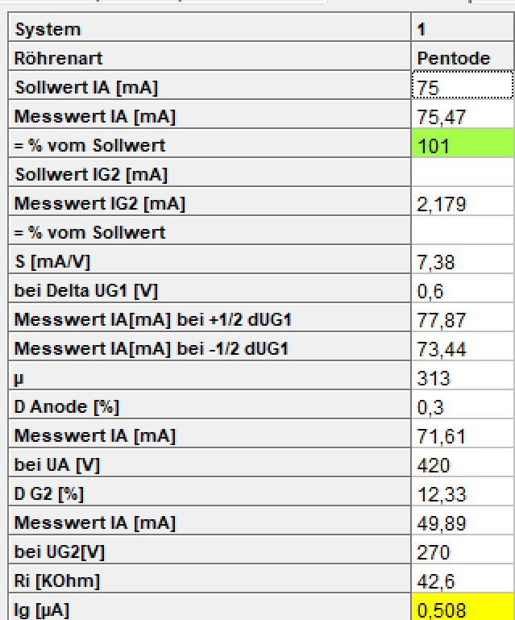
Vacuum test: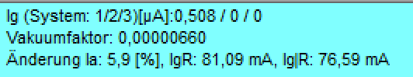

Time course (after approx. 30 seconds of pause/cooling down and restart):
(new alternating mode:red=hard G1 control,blue= grid over resistance)
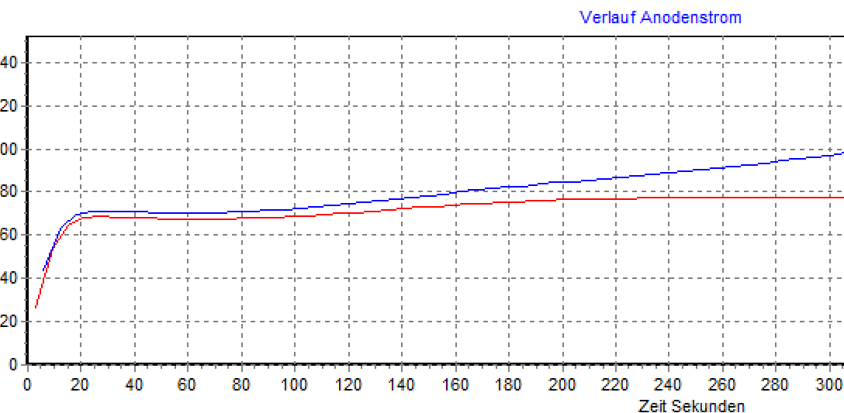

Ua 600V, Ug2 300V, Ug1 -27V,
Rug= 1.2MOhm
Measurement every 3 seconds, sound test off

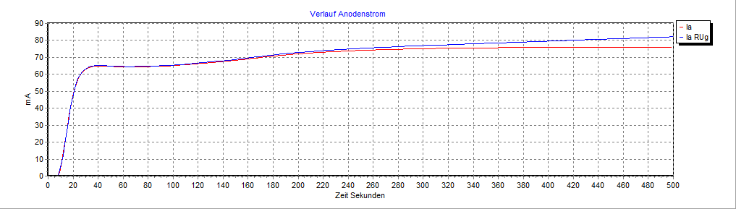
Ua 600V, Ug2 300V, Ug1 -27V, RUg= 200KOhm,
Measurement every 3 seconds, sound test off
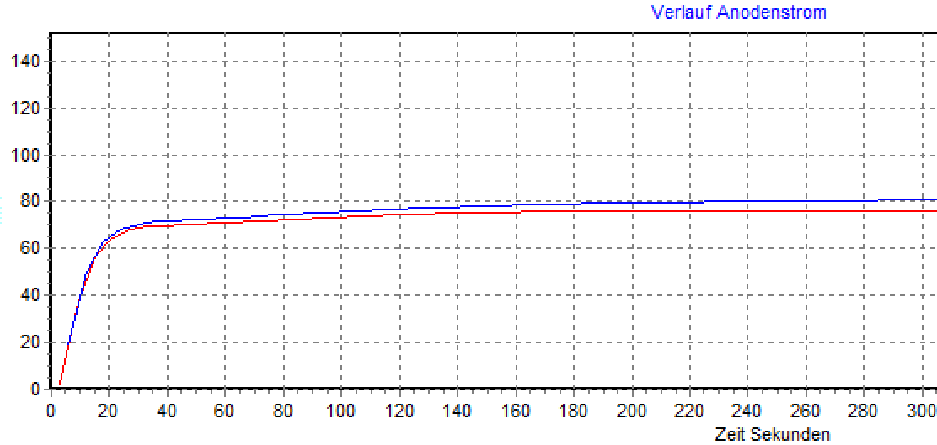
Ua 600V, Ug2 300V, Ug1 -27V, RUg= 100KOhm,
Measurement every 3 seconds, sound test off

Conclusion:Tube has increased grid current. Tube at RUg=1.2MOhm or 200 KOhm runs out of time. Stable at 100KOhm. If sound test is on, then no noise (with and without 1.2 Mohm/100 KOhm resistor). When warmed up (from a cold tube), the characteristic curve has a strange hill starting at around 120S, and goes into a straight line when warm.

Tube 3:

Thread test: ok
Short circuit test: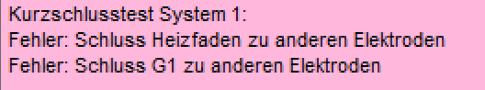

In the diagram sent (characteristic curve over time), the anode current rises steeply. This is not surprising since the grid is connected to the thread and is therefore always at 0V. You can also tell in the static measurement that the measuring instrument for the grid voltage shows 0V and not -27V.

Further tests on this defective tube are not possible.

Tube 4:
Thread test: ok
Short circuit test: ok
stat. Measurements:
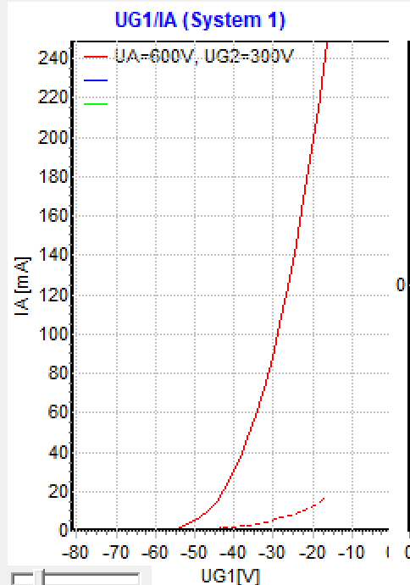
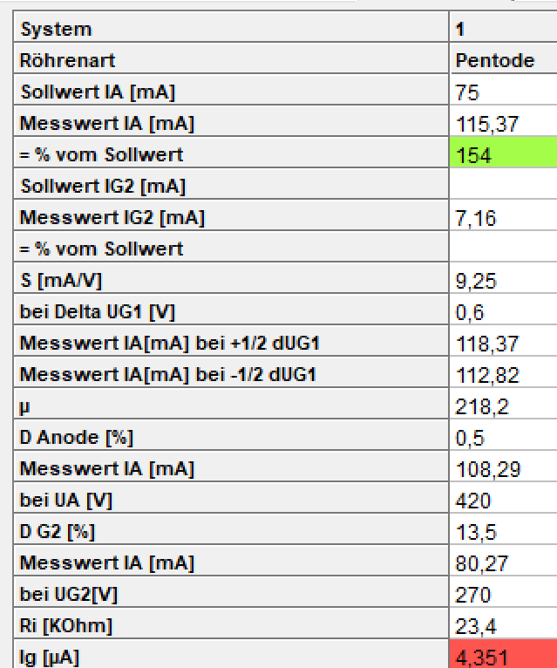
Vacuum test: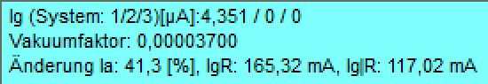
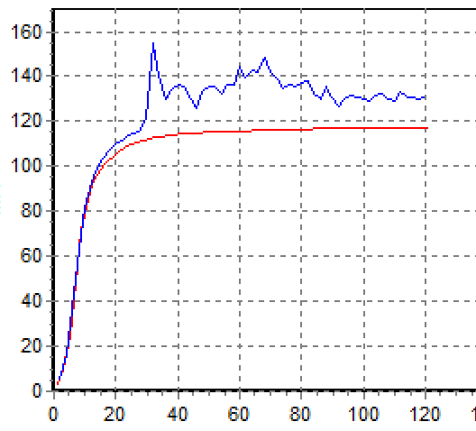
Ua 600V, Ug2 300V, Ug1 -27V,
Rug= 1.2MOhm
Measurement every 1 second, sound test off
Measurement alternately every second
Zigzag curve??? What could be the cause?
Vibrations? (probably not, since voltages are constant)
The sound test says: Strong noises in high-omimic operation (at 1.2 MOhm!! Hence the strong zigzag.As soon as the tube is really hot, the cracking disappears.

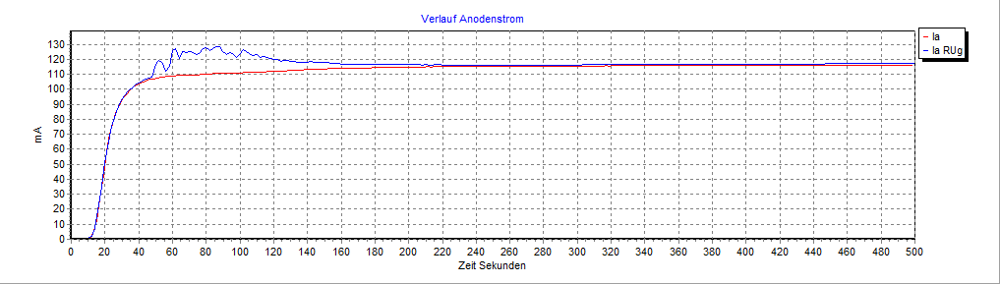
Ua 600V, Ug2 300V, Ug1 -27V, RUg= 200KOhm,
Measurement every 3 seconds, sound test off

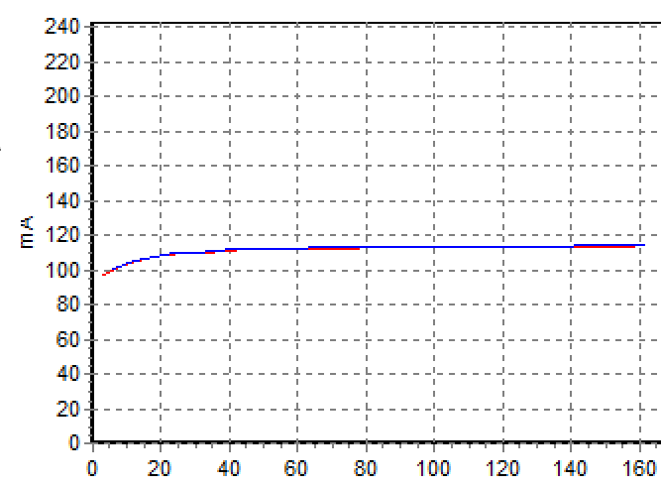

Again with 100 KOhm:

Cracking noises can also be clearly heard here.
As soon as the tube is really hot, the cracking disappears.

Tube 5:
stat. Measurements:
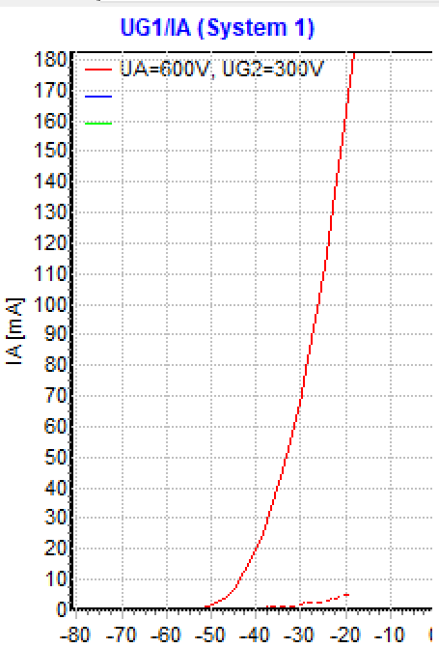
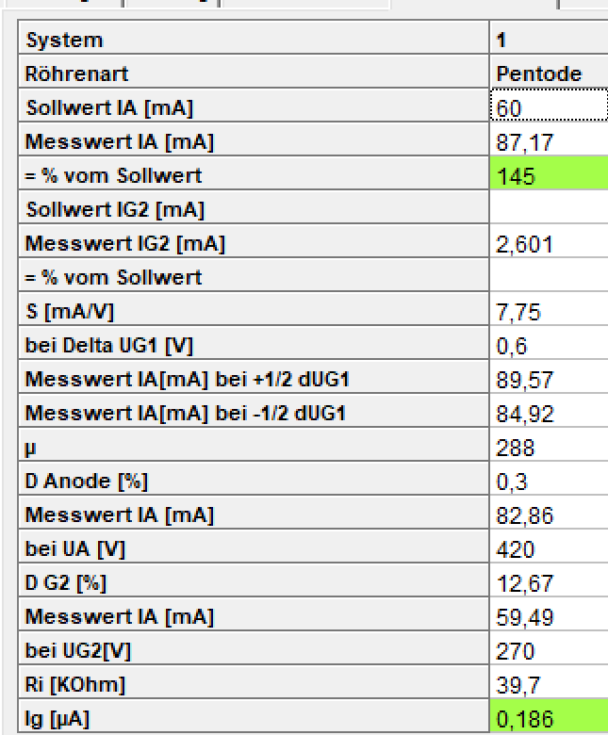
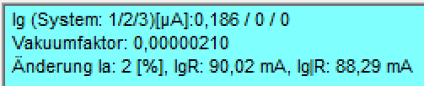

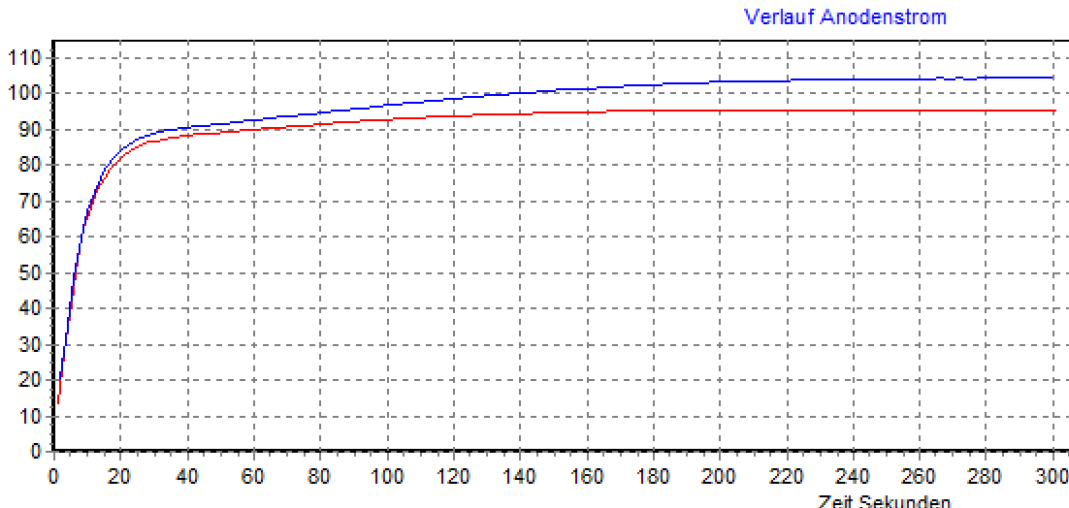

Ua 600V, Ug2 300V, Ug1 -27V, RUg= 1.2MOhm
Measurement every 1 second, sound test off

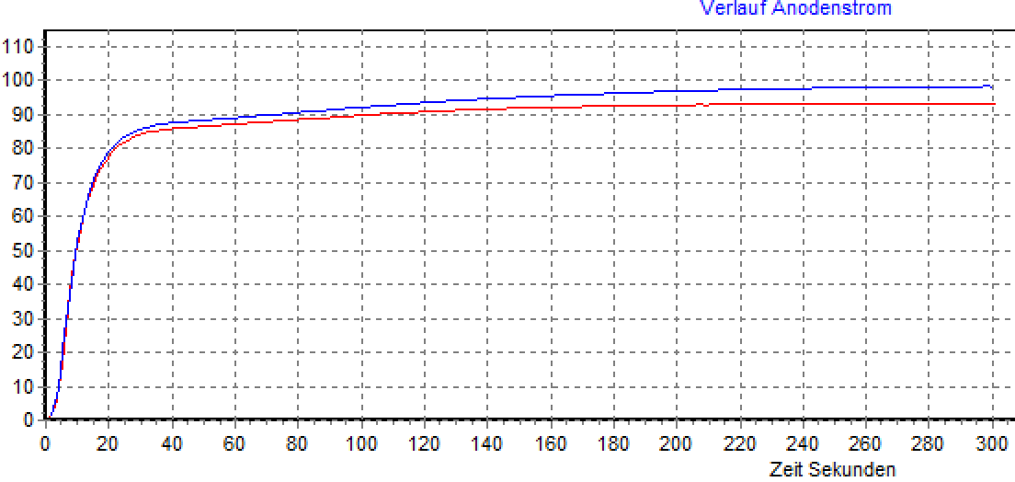

Ua 600V, Ug2 300V, Ug1 -27V, RUg= 1.2MOhm
Measurement every 1 second, sound test on

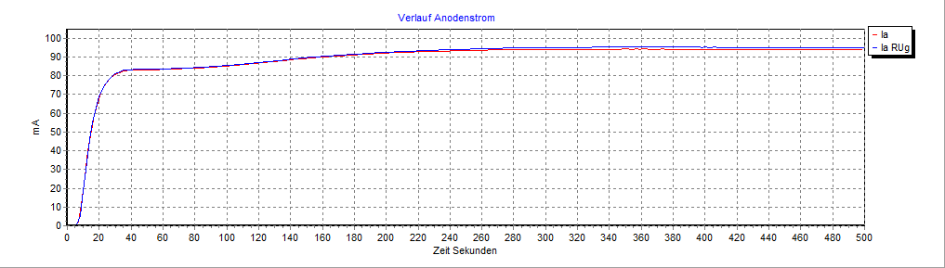
Ua 600V, Ug2 300V, Ug1 -27V, RUg= 200KOhm,
Measurement every 3 seconds, sound test off

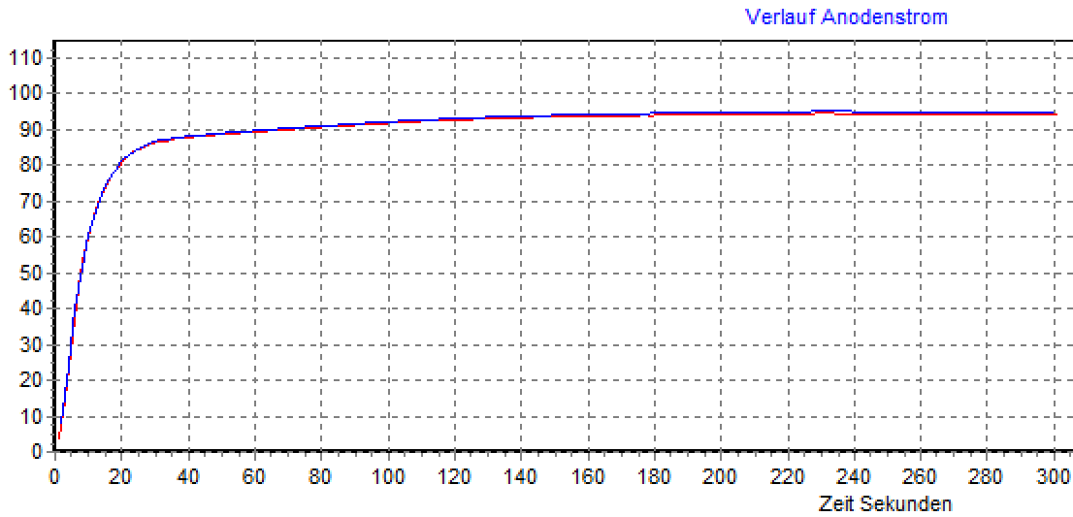
Ua 600V, Ug2 300V, Ug1 -27V, RUg= 100 KOhm
Measurement every 1 second, sound test off

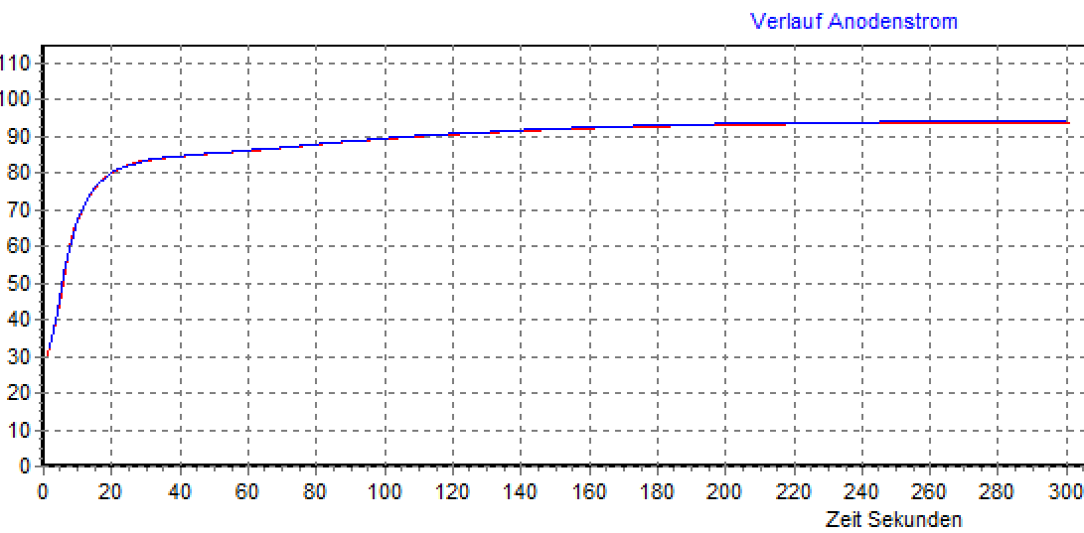
Ua 600V, Ug2 300V, Ug1 -27V, RUg= 100 KOhm
Measurement every 1 second, sound test on

Conclusion:Tube has low grid current. Tube is stable. Tube would also be stable with larger RUg Sound test: No noises.

Generally:
1. For the KT88, the RUg of 200 KOhm is suitable (within the limit). The currents without and with resistance in the grid line are approximately the same. 1.2 Mohm would be too high for the KT 88. Sound test (switching on the output transformer) has no significant effect on the characteristic curve.

Tube 6:
stat. Measurements:
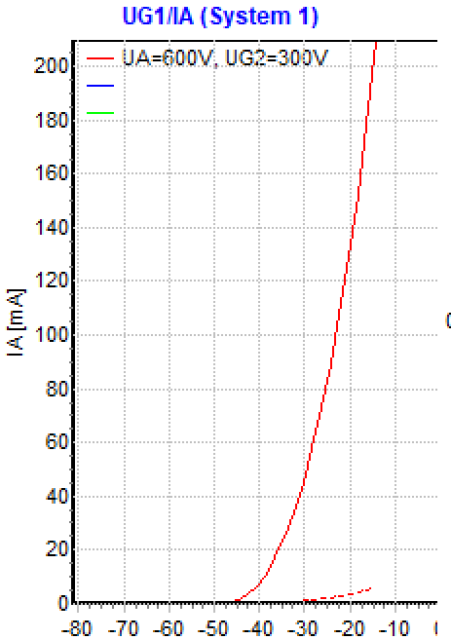
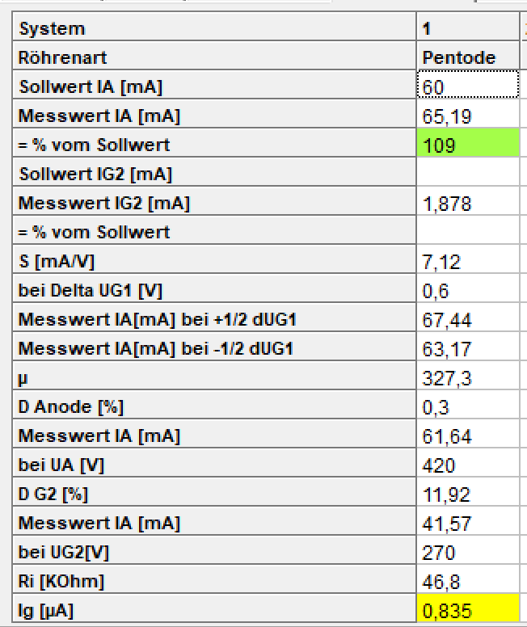

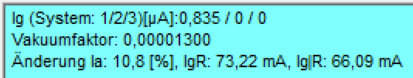

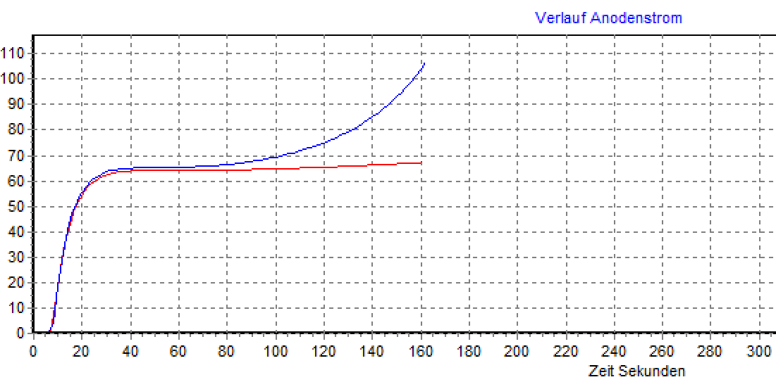
Ua 600V, Ug2 300V, Ug1 -27V, RUg= 1.2MOhm
Measurement every 1 second, sound test off

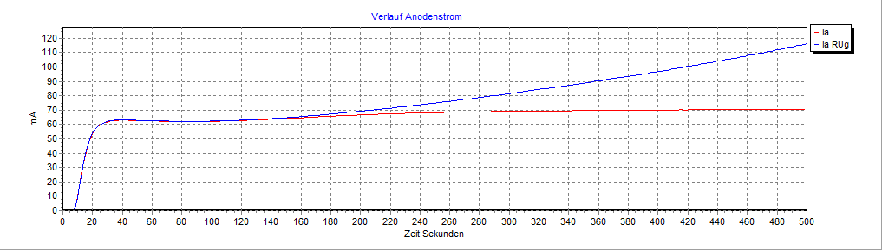
Ua 600V, Ug2 300V, Ug1 -27V, RUg= 200KOhm,
Measurement every 3 seconds, sound test off

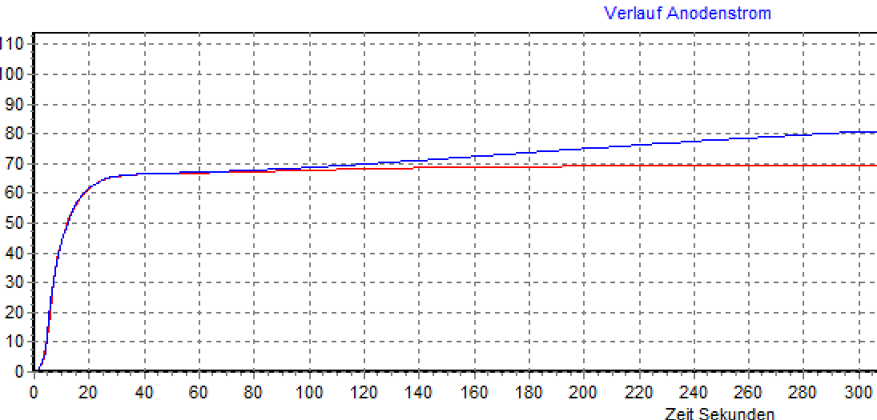
Ua 600V, Ug2 300V, Ug1 -27V, RUg= 100 KOhm
Measurement every 1 second, sound test off

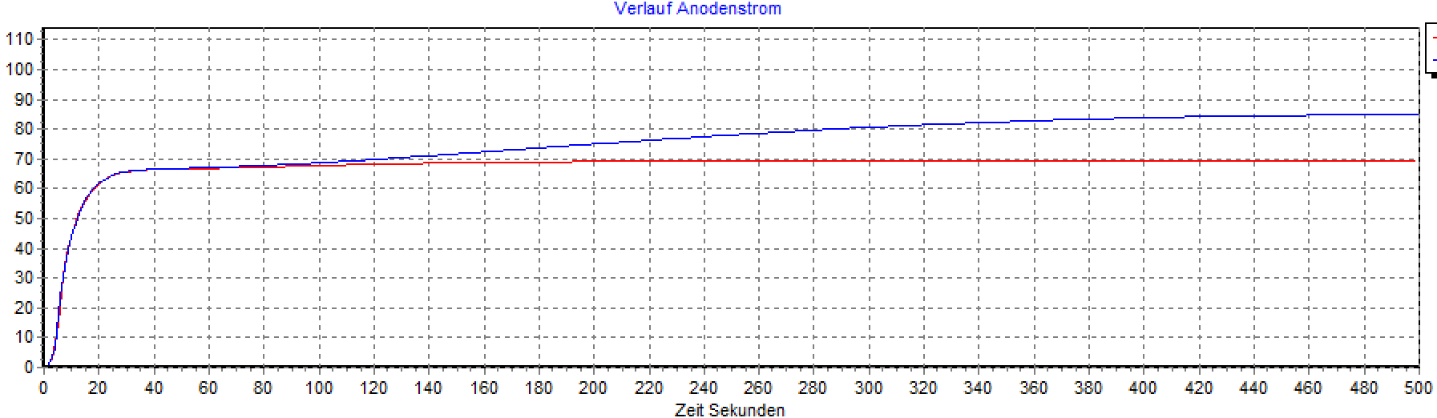
same shot – longer time

Conclusion:
Grid current range yellow: At 1.2 Mohm and 200 Kohm the tube runs away. At 100 KOhm the current increases, but after a while it turns into a straight line. Tube would still be usable if there was enough low-resistance control, but not as stable as tube 5. At 1.2 Mohm the deflection is so strong that you can recognize the problem early on, but you don't see that at 100 KOhm the line later turns into one Just about goes.

================================================= =====================

Consideration of tube power loss:

Limit values ​​according to data sheet:

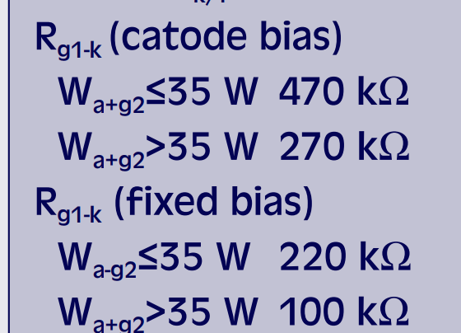
With >35 W and fixed bias (the measuring conditions), grid control with a maximum of 100 Kohm would be permitted. However, the blue characteristic curve is measured at 1.2 Mohm and is therefore far above the permissible limit of the data sheet (for tubes with more than 100% emissions).

If the anode power loss remains below 35 watts, the maximum permissible grid resistance is 220 KOhm.
!

In particular, tube number 4 is operated with the measurement data of Ua 600V, Ug2 300V and Ug1 -27V above the power limit (>70 watts with permissible anode power loss of 42 watts). The tube gets very hot! It is advisable to choose a different operating point for the measurements in order to stay within the limit values).

Another measurement of tube 4 with Ua 600V, Ug2 300V and Ug1 -35V:

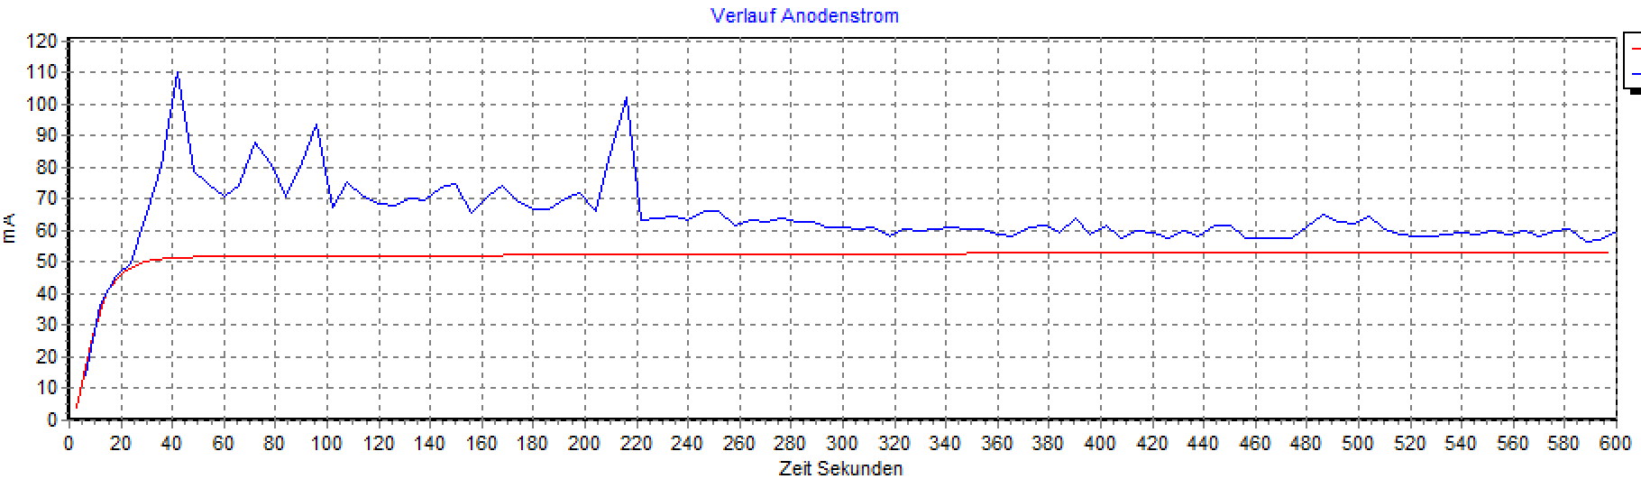
Even if the tube cracks a lot and the characteristic curve is jagged, it is clearly visible that it is not running away. It is therefore important to stay within the limits regarding power loss so that the tube does not overheat!!! Regardless of the incorrect measurement result due to overload, the tube could be damaged during this long-term measurement.

================================================= =================

Overall findings:

1. The grid current (vacuum test) measured in the static test is very informative (heat up long enough, at least 120 seconds for the KT88). From this one can already draw conclusions about the long-term behavior/expected drift of the tube.

2. Regarding the resistance in the grid line, the data sheet should be taken into account with regard to the maximum permitted grid resistance. With the KT88 a maximum of 220 KOhm (with fixed grid bias) is permitted. When measured at 1.2 MOhm, well outside the permitted limit, most tubes run away. Only tube 5 with grid current in the green range would still work even with this high-resistance control. For long-term measurements, a value of 200 Kohm shows a practical value at which a good/bad distinction can be made. This resistance value should also be suitable for many other power tubes.

3. The “alternating” measuring mode, i.e. alternating with RUg=0Ohm and RUg=200KOhm (or 1.2 MOhm), shows the quality of the tubes with regard to the grid current with the distance between the characteristic curves.

4. A sound test is useful for cracking tubes (but is also possible in static measurement batch mode).

5. Unfortunately, many data sheets are silent regarding the maximum permitted grid resistance. I assume that there is nothing special for most (pre-)tubes and that they can easily be controlled with high resistance (1.2 MOhm). A limit is often only given for power tubes. Here the 200 KOhm represents a practical value.

6. Consideration RoeTest:
Currently available:
- Low-resistance grid control with 0 ohms, necessary for all static measurements and characteristic curve recordings
- High-resistance control with 1.2 MOhm, necessary for vacuum measurement/grid current measurement and long-term measurement, for tubes that allow high-resistance control
still necessary:
- Medium-resistance control with 200 KOhm, necessary for long-term measurements, for tubes that only allow medium-resistance control (e.g. KT88). Also for those with a maximum permitted grid resistance of up to 500 KOhm.

7. Realization in the RoeTest (attention only from hardware V10):
Adding hardware is easy. Firmware, motherboard and processor board already meet all the requirements. Only the G1 board needs to be supplemented with a relay, a resistor (240K) and some wires:

Hardware conversion – G1 card (only from V10):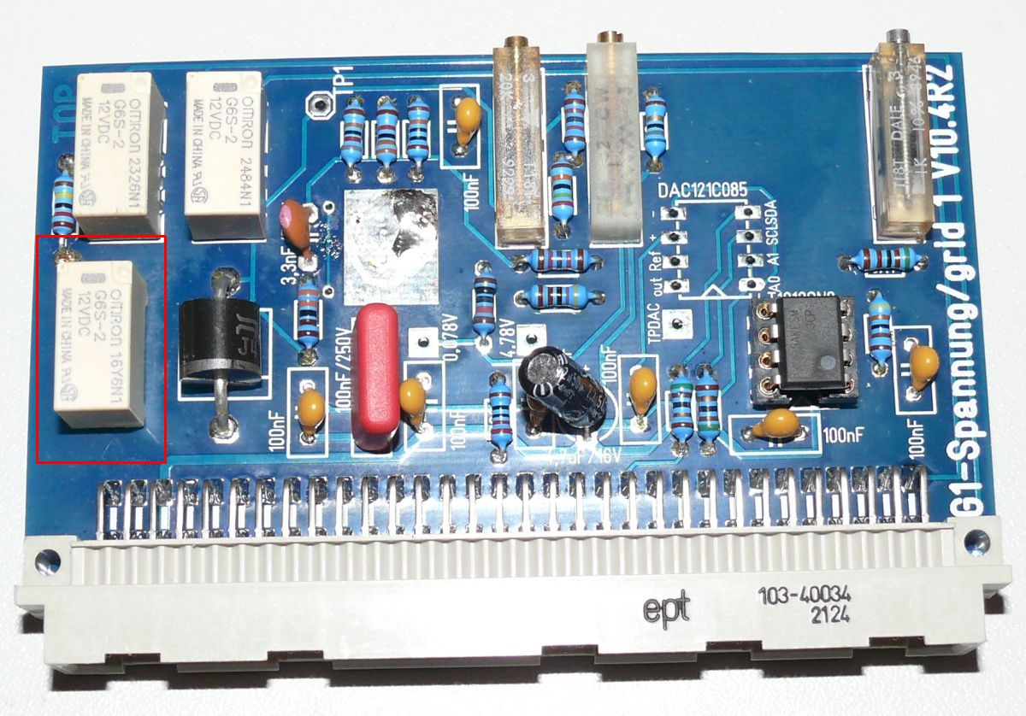
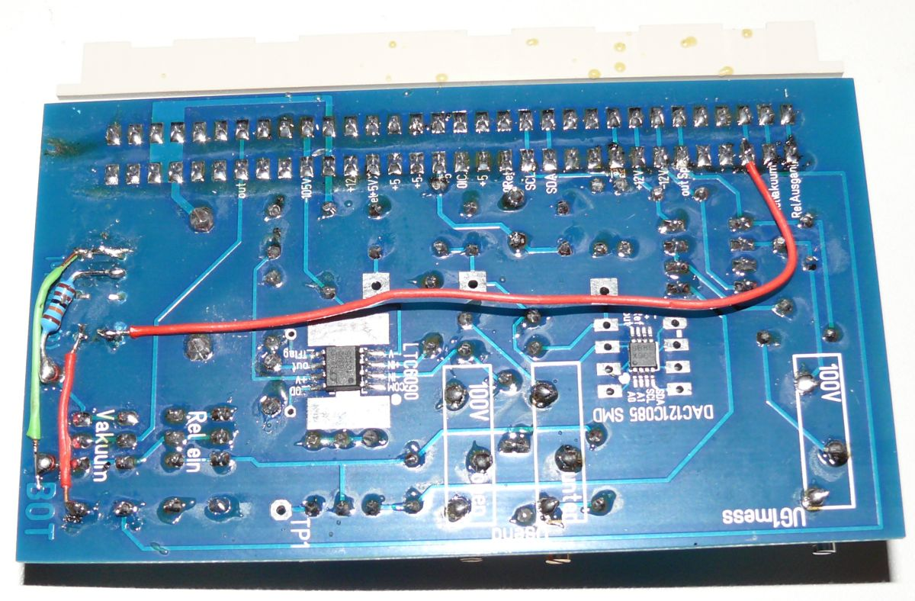
With the relay, a resistor of 240 K can be connected in parallel to the previous resistor of 1.2 MOhm. This then results in around 200 KOhm.
Relay: Omron G6S-2 12V
G1 card version 10 becomes version 11

Software:

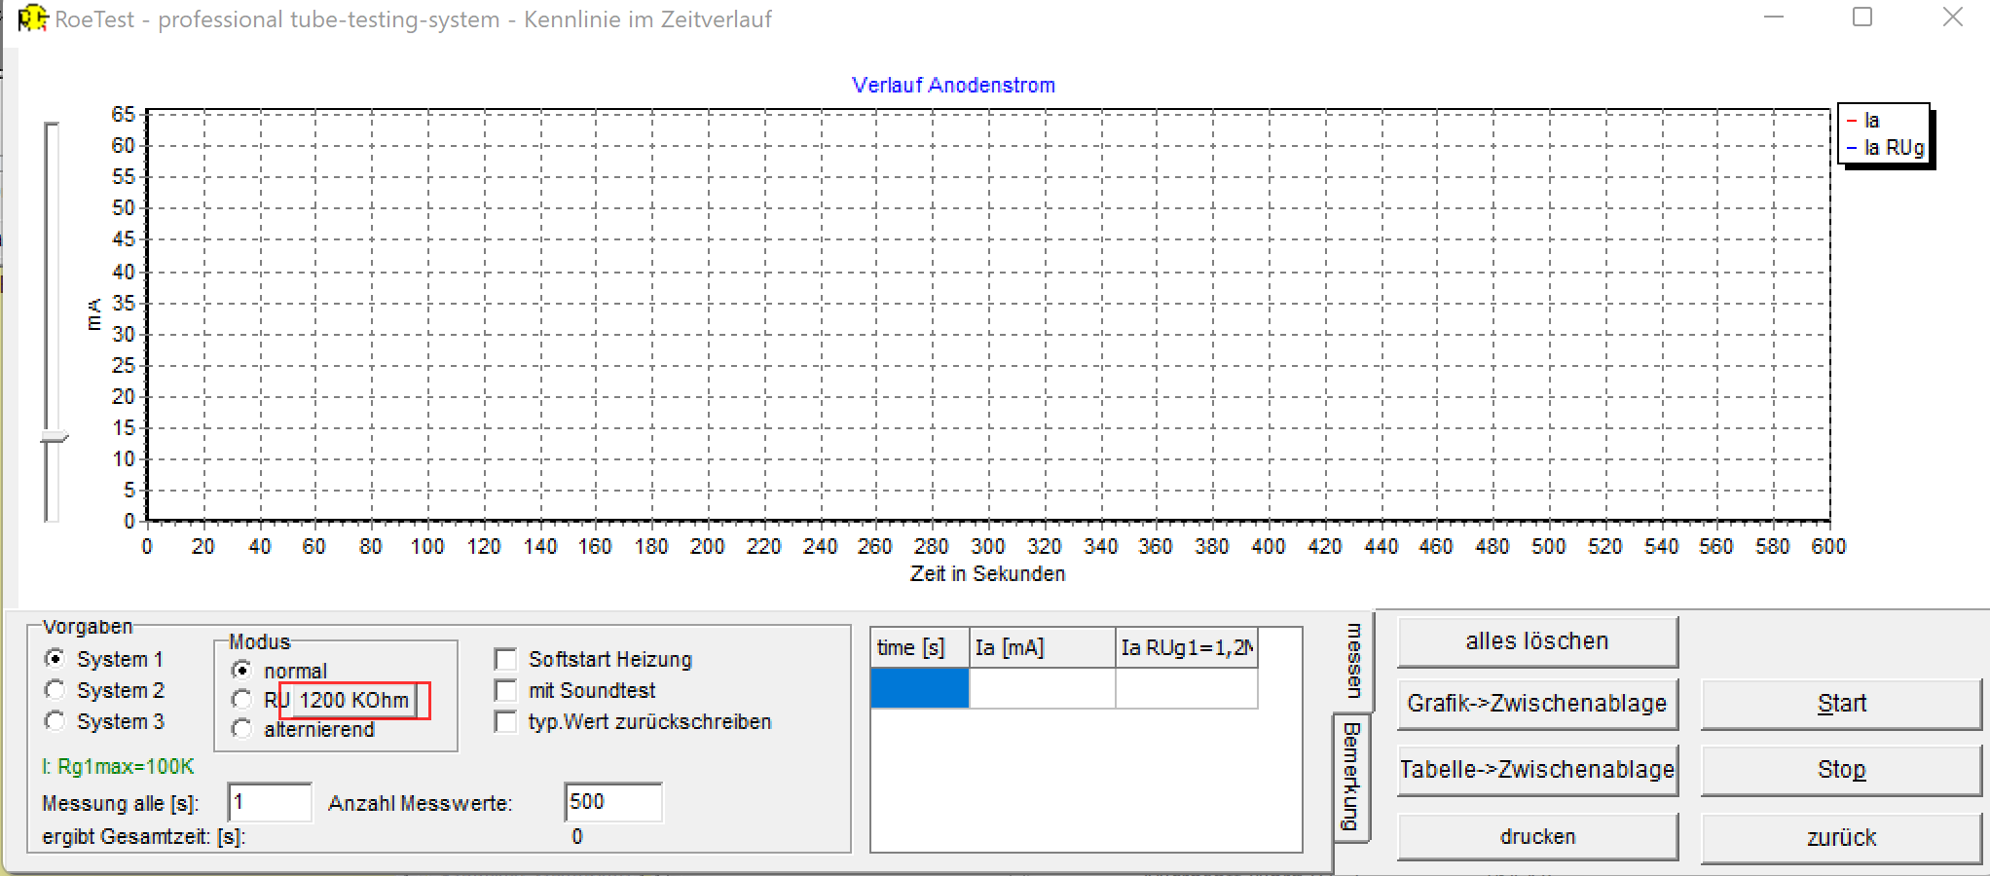
A button allows you to switch between 1.2 MOHm and 200 KOhm (of course only if the G1 card is converted to V11 and the software is told the new card version - Tab C→Options/Test→Options):
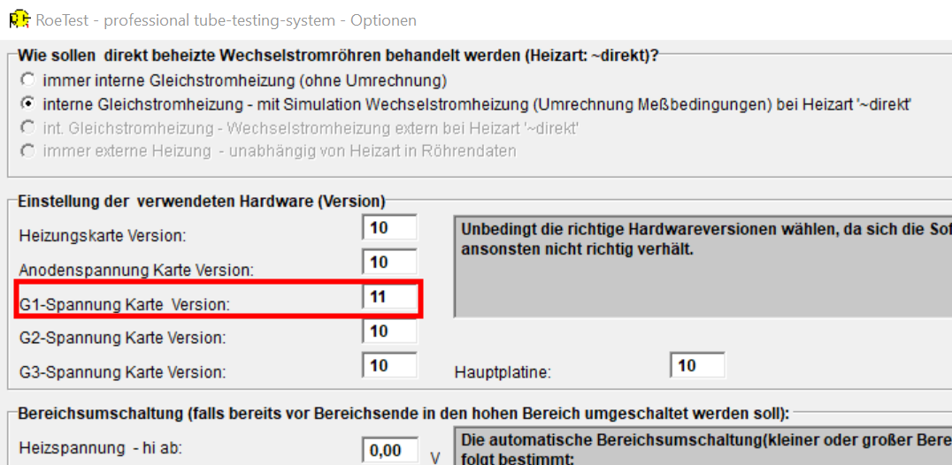

This means that long-term measurement can take place automatically without having to connect an external resistor.

The new relay can be tested in the software (Tab C→Options/Test→Relay):

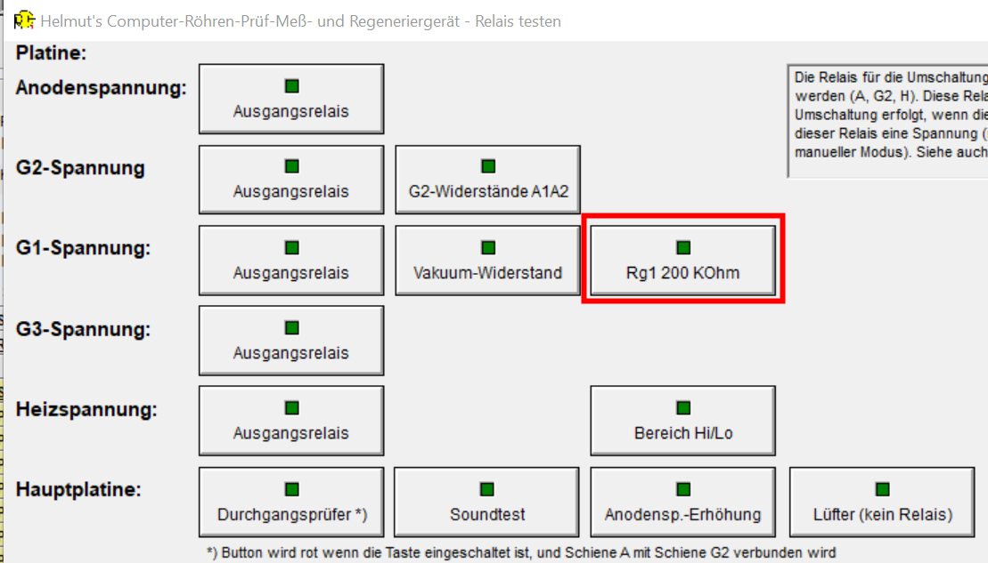
________________________________________________________________________

For the KT88 I recommend making the following settings:
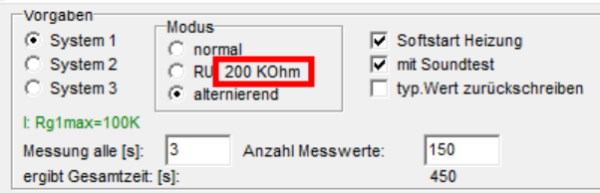
- alternating: Shows two characteristics, one with 200 Kohm and one without resistance,
- 200 Kohm: By pressing the button you switch from 1.2 Mohm to 200 Kohm
- Soft start: So that there is no interruption when the tube is cold
- Sound test: Optionally with (output transformer and amplifier must be connected) or without
- Measurement every 3 S (1S is also possible, but then the device often switches back and forth between 0 and 200 Kohm)

You can also make all settings from batch processing.

